UNCG School of Nursing
Class of 2019 Fall Fundraiser

The Class of 2019 will be selling These Padfolios with the Minerva and UNCG School of Nursing design screen printed in silver as shown on the right
You can preorder your own for just $15

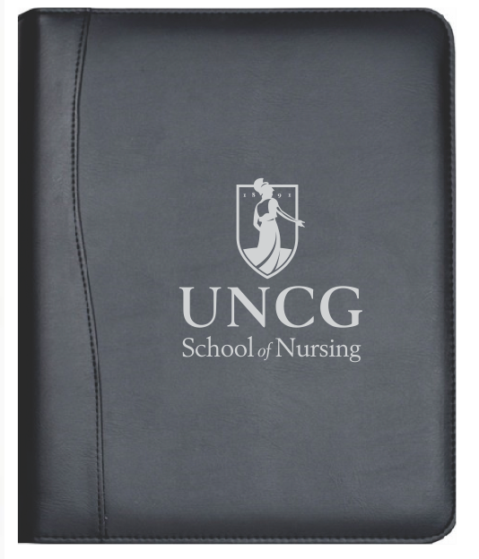
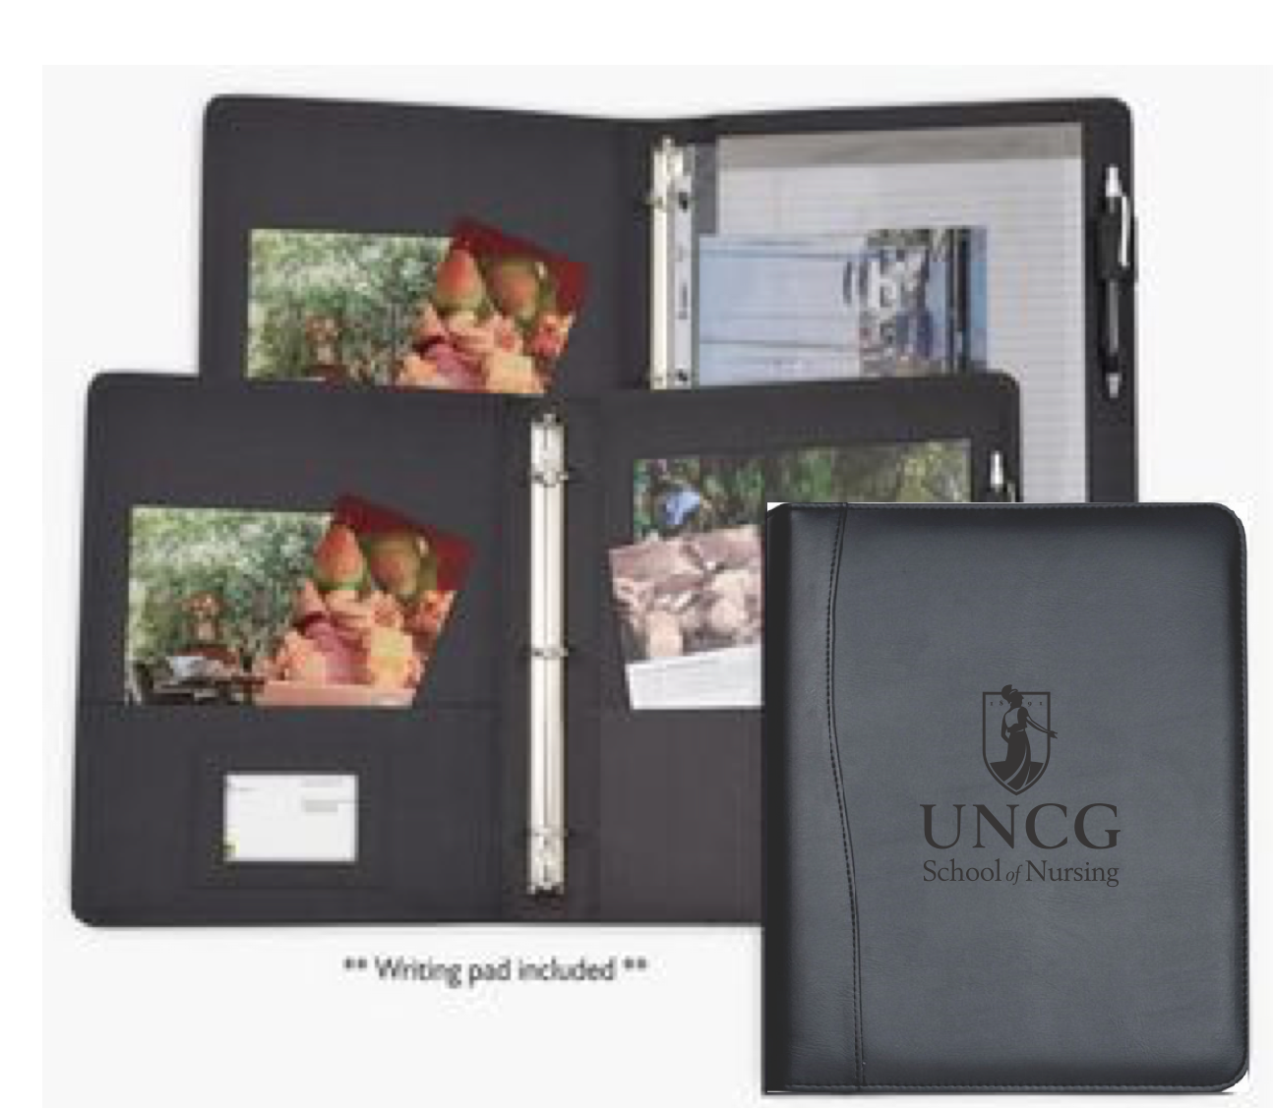
To do so, please complete this order form and place in an envelope with your money, by Monday, March 19th
You can drop the orders off outside of room 418 in the School of Nursing Building.

**Megan Anibal will be in the 4th floor student lounge (Moore Building) on Wednesday, March 14th from 12:30-4pm and Monday the 19th from 11am to 3pm collecting also**

Name: Email:

Quantity: Total Price: .

These padfolios will provide a professional start to your nursing portfolio, take notes or present in an interview!
We encourage you all to share this with your friends and family.
***We thank you for your support***

